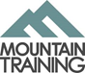
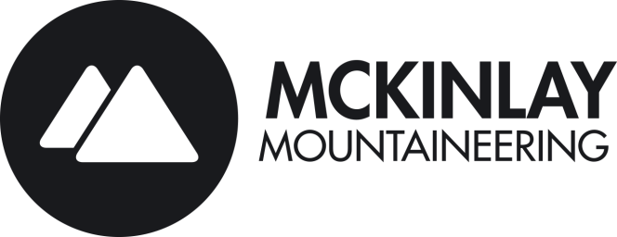
Mckinlay Mountaineering is an approved Mountain Training provider enabling us to deliver their industry standard awards. This allows us to provide training and assessment for the Mountain Leader (ML), Rock Climbing Instructor (RCI), Climbing Wall Instructor (CWI) and Climbing Wall Development Instructor (CWDI). We now are the largest provider of Mountain Training awards in the North of England.
The Mountain Leader award (ML) is administered by the Mountain Training and trains and assesses candidates in the skills required to lead a group of hill walkers anywhere in the UK under summer conditions. As such it is seen as an essential qualification for those wishing to work in the outdoors industry and with outdoor centres, school groups and the voluntary sector.
The ML is also a vital tool for hill walkers and mountaineers wanting to review their personal skills, allowing them to expand their knowledge of current best practise.
To be awarded the ML a candidate must complete the training course and pass the separate assessment. All candidates should leave a minimum of 6 months between training and assessment courses in order to consolidate the techniques learned and to develop their own personal and group skills.

Pre-requisites for ML Training
Before you come on a training course you must be
- 18 or over
- have registered for the scheme with the Mountain Training MT
- have completed at least 15 to 20 quality mountain days

Please note that you will need to have registered for the scheme and have completed your DLOG. Failure to do so may result in the course being invalid for that individual.

Price:
- ML Training/Assessment without accommodation or food £350.00
- ML Training/Assessment with accommodation in YHA Self Catering £425.00
- Bespoke courses are worked out on an individual basis.

Payment:
Payment is made via the website. Please note the full amount is payable immediately. Alternatively payment can be made by cheque or bank transfer payee Mckinlay Mountaineering. Our details are account 29548861 sort code 601239. We will contact you as soon as payment has been made.

Accommodation
Mckinlay Mountaineering is proud to be partners with the YHA, who are the leading hostel providers in the UK. Being partners we can offer great accommodation at Hostels where our ML Courses will be based. Please note; you will need to bring your own food for the expedition element, meals, snacks and drinks. Accommodation includes 2 nights’ accommodation from Friday night leaving Sunday on the first weekend and one night accommodation on Friday night only as we will be wild camping on the Saturday night.

Itinerary
Please arrive at Petes Eats 9.30am Monday morning. The course will start promptly so please be kitted up and ready to go at this time. Timings from day 2 onwards will be a 09:00 start unless Course Director says otherwise.
Timings | Meeting | Course Content (Day) | Course Content (Evening)
Day 1  09:30  First weekend | Pete’s Eats Café, Llanberis | Arrival and Introduction to Mountain Leader Scheme and course. Intro navigation, group kit. | Introduction to mountain weather.
Day 2 | YHA Llanberis North Wales | Mountain Day – navigation, access, conservation, environment. | Leader/group equipment.
Day 3 | YHA Llanberis North Wales | Mountain Hazards, steep ground.
Day 4  9.30 Second weekend | Pete’s Eats Café, Llanberis North Wales | Group Management, steep terrain, group control, leadership styles and navigation. | Route planning exercise/ expedition preparation
Day 5-6  Finish approx. 14:00 | North Wales | Expedition phase;  Camp-craft & expedition skills  Mountain/Water Hazards  Group leadership  Macro Navigation: Day & Night  Emergency procedure  Finish expedition, course& individual debrief and review

Kit List:
Please provide your own maps and compass (silva type 4 is highly recommended)
Maps: Ordinance survey explorer OL17 Snowdon
I will supply either a Harvey British Mountain Map BMC Snowdonia 1:40,000 or Landranger 115 Snowdon1:50,000

This suggested equipment list is in addition to your normal hill-walking clothes
Personal
Rucksack Individual first aid
Bivvy bag / Survival bag Compass / Whistle / Watch
Map cover Waterproof jacket & trousers
Hat / Gloves Spare fleece
Headtorch / Spare batteries Emergency food
Flask

Please bring old clothes, trainers and towel for the river crossing
Please remember: clothes that dry quickly and are light weight should be used during the course if possible.

Expedition
Tent (suitable for wild country) Stove / Fuel / Pans / Matches
KFS / Bowl / Mug Sleeping Bag / Karrimat
Spare clothes Toiletries
Water carrier Expedition food
Expedition rucksack & waterproof liner Water purifying tablets

Please note this list is only a guide. If you need to borrow any piece of kit I must know in advance. I have a small supply of tents and stoves. The individual must supply all other kit. I will not be able to lend kit during the course.

All items are brought with the knowledge that Mckinlay Mountaineering takes no responsibility for the loss or damage of these items. These are the sole responsibility of the candidate.

Transport:
No transport is included but we are happy to car share.

Recommended Reading:
Please refer to your Mountain Leader Award handbook for details with regards to the syllabus and remit of the Mountain Leader Award qualification. If you need a copy, this can be downloaded from the Mountain Training website. Please also refer to the below titles for further reading:
- Hillwalking – The official handbook of the ML and HML schemes which can be purchased from the Mountain Training, BMC, Amazon websites.
- Hostile Habitats - Scotland's Mountain Environment: A Hill walkers' Guide to Wildlife and the Landscape
This is a fantastic guide to the UK’s mountain fauna, flora and landscape written for hill walkers.
- Mountaincraft and Leadership by Eric Langmuir – which can be purchased on Mountain Training, BMC or Amazon websites.

